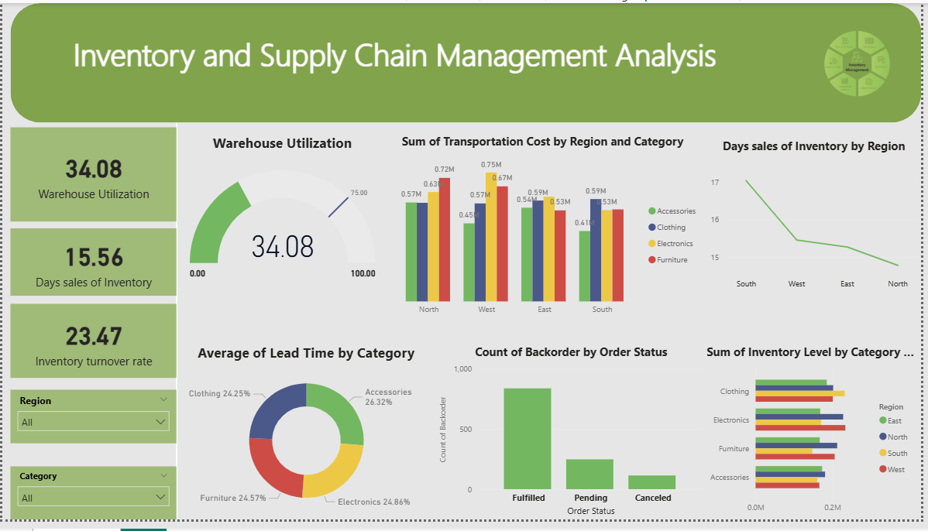
This report provides an analysis of the Inventory and Supply Chain Management dashboard. It breaks down current operational performance, cost distributions, and inventory efficiency metrics.

Inventory and Supply Chain Management Analysis Report

1. Executive Summary
The dashboard highlights a current Warehouse Utilization of 34.08%, indicating significant available capacity for inventory expansion. Supply chain efficiency is further defined by a Days Sales of Inventory (DSI) of 15.56 and an Inventory Turnover Rate of 23.47, suggesting a relatively high-velocity movement of goods.

2. Key Performance Indicators (KPIs)
The following high-level metrics track overall supply chain health:
Metric | Value | Status/Interpretation
Warehouse Utilization | 34.08 | Underutilized; room for growth.
Days Sales of Inventory (DSI) | 15.56 | Goods move from stock to sale in ~16 days.
Inventory Turnover Rate | 23.47 | High efficiency in replacing inventory over a period.

3. Cost and Regional Insights

A. Transportation Costs by Region and Category
Transportation spending varies significantly across the four primary regions:
- North: Highest costs are associated with the Furniture category ($0.72M).
- West: Leads in Clothing transportation costs ($0.75M), which is the single highest expenditure category in any region.
- East & South: Show more balanced spending, though Clothing remains a high-cost driver in the South ($0.59M).

B. Days Sales of Inventory (DSI) by Region
There is a clear geographic trend in inventory aging:
- South: Exhibits the slowest inventory movement at 17 days.
- North: Shows the highest efficiency with the lowest DSI, dropping to just under 15 days.
- Trend: Inventory flows more efficiently in Northern and Eastern regions compared to the South and West.

4. Operational & Inventory Metrics

A. Lead Time and Backorders
- Lead Time by Category: Average lead times are evenly distributed across categories, with Accessories requiring the most time (26.32%) and Clothing the least (24.25%).
- Order Status: The majority of backorders are Fulfilled (near 800 units), while approximately 250 orders remain Pending. Canceled orders are minimal, suggesting high reliability in order processing despite backorder status.

B. Inventory Levels by Category and Region
- Electronics: Shows the highest inventory levels, particularly in the West and South regions.
- Accessories: Maintains the lowest overall inventory levels across all regions.
- Clothing: Inventory levels are consistently high in the South, aligning with high transportation costs in that region.

5. Observations & Recommendations
- Optimize Warehouse Capacity: With utilization at only 34.08%, the organization should investigate consolidating storage or increasing stock levels in high-demand categories to maximize facility ROI.
- Reduce Transportation Costs in the West: The $0.75M cost for Clothing in the West is an outlier. Investigating carrier contracts or route optimization in this region could yield significant savings.
- Address Lead Times for Accessories: As Accessories have the highest lead time (26.32%), reviewing supplier performance or logistics for this category could improve overall responsiveness.
- Improve Southern Region Turnover: Since the South has the highest DSI (17 days), localized marketing or promotions may be needed to accelerate inventory movement in that market.

